We use ‘an’ before a word that begins with a vowel. Also we use ‘a’ before a word that begins with consonants.

I. Fill in the blanks with ‘a’ or ‘an’.
1.________egg in___________basket.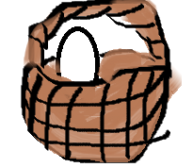

2._________man in ____________aeroplane.

3.________boy on _________elephant.

4._______girl with_________umbrella.

5.________pen in_______inkpot.

6.________ice cube in _______glass.

7.________frog in ______well.

8._________lock and ______key.

9.______spoon and _______fork.

10._______parrot in ______cage.

11.________rabbit and _______tortoise.

12._______girl and _________boy.

13._________monkey with_______cap.

14._________dog in ________kennel.

15._________mouse and__________ cat.

